

**ROBOTIC PROCESS AUTOMATION SIG COMIBLOC OBEIKAN**

PROCESS DEFINITION DOCUMENT (PDD)

OGC & OFF Account Payable Invoice Posting in SAP



Jibran Umer

j.umer@obeikan.com.sa



Document History

|  |  |  |  |  |  |  |  |  |  |  |  |  |  |  |  |  |  |  |  |  |
| --- | --- | --- | --- | --- | --- | --- | --- | --- | --- | --- | --- | --- | --- | --- | --- | --- | --- | --- | --- | --- |
|  | Date |  |  | Version |  |  | Role |  |  | Name |  |  | Organization |  |  | Function |  |  | Comments |  |
|  |  |  |  |  |  |  |  |  |  |  |  |  |  |
|  |  |  |  |  |  |  |  |  |  |  |  |  |  |  |  |  |  |  |  |  |
| 24.06.20 | |  | 1.0 | |  |  | Finance | |  | Jibran Umer | |  | *SIG Combibloc* | |  | Accounts Payable | |  | Created document v1.0 | |
|  |  |  |  |  |  |  |  |  |  |  | |  | *Obeikan* | |  |  | |  |  |  |
|  |  |  |  |  |  |  |  |  |  |  |  |  |  |  |  |  |  |  |  |  |

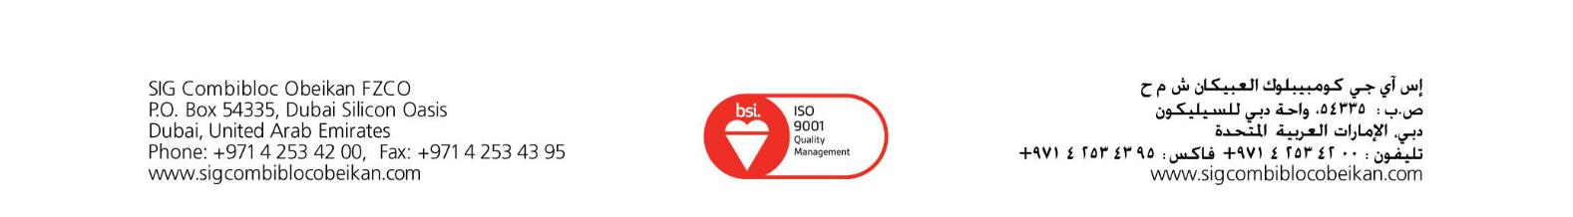

Contents

|  |  |  |  |  |
| --- | --- | --- | --- | --- |
| 1. | Introduction | | | 3 |
|  | 1.1 | Purpose of the document | | 3 |
|  | 1.2 | Objectives | | 3 |
|  | 1.3 | Process key contacts | | 3 |
|  | 1.4 | Minimum Pre-requisites for automation | | 4 |
| 2. As IS process description | | | | 4 |
|  | 2.1 | Process Overview | | 4 |
|  | 2.2 | Applications used in the process | | 5 |
|  | 2.3 | As IS Detailed Process map | | 5 |
|  | 2.4 | Additional sources of process documentation | | 6 |
| 3. To BE Process Description | | | | 7 |
|  | 3.1 | TO BE Detailed Process Map | | 7 |
|  | 3.1.1 |  | Change/Improvement details | 8 |
|  | 3.1.2 |  | Areas already automated | 8 |
|  | 3.2 | In Scope for RPA | | 8 |
|  | 3.3 | Out of Scope for RPA | | 9 |
|  | 3.4 | Business Exceptions Handling | | 9 |
|  | 3.4.1 | | Known Exceptions | 9 |
|  | 3.4.2 | | Unknown Exceptions | 10 |
|  | 3.5 | Application Error and Exception Handling | | 10 |
|  | 3.5.1 | | Know Errors or Exceptions | 10 |
|  | 3.5.2 | | Unknown Errors and Exceptions | 10 |
| 4. | Document Approval | | | 11 |



1. Introduction

1.1 Purpose of the document

The Process Definition Document outlines the business process chosen for automation using UiPath Robotic Process Automation (RPA) technology.

The document describes the sequence of steps performed as part of the business process, the conditions, and rules of the process prior to automation and how they are envisioned to work after automating it, partly or entirely. This specifications document serves as a base for developers, providing them the details required for applying robotic automation to the selected business process.

1.2 Objectives

The business objectives and benefits expected by the Business Process Owner after automation of the selected business process are:

* *Reduce processing time per item by 80 %. The duration to process an invoice in AS IS state is 5 minutes.*
* *Cost Saving specifically the saving derived from the FTE reduction after Automation*
* *Productivity Gain resulting from the overall improvement in Turnover Time as well as the Average Handling Time*
* *Another benefit is quality increase and error Reduction. The robots run as configured so the error rate is 0%*
* *Another key Benefit is compliance to regulatory Requirements*
* *Finally, another key benefit is Flexibility. if transaction volume is expected to rise, robots can be scaled up to handle the extra load*

1.3 Process key contacts

The specifications document includes concise and complete requirements of the business process and it is built based on the inputs provided by the **process Subject Matter Expert (SME)/ Process** **Owner.**

The **Process Owner** is expected **to review it and provide signoff for accuracy** and completion of the steps, context, impact and complete set of process exceptions.

Below are the details of all key contacts:

|  |  |  |  |
| --- | --- | --- | --- |
| ***Role*** | ***Name*** | ***Contact Details (email, phone number)*** | ***Notes*** |
| Process SME | Jibran Umer | [j.umer@obeikan.com.sa Mobile: +966540674360](mailto:j.umer@obeikan.com.sa%20%20%20%20%20%20%20Mobile:%20+966540674360) | Point of contact for questions related to process details & exceptions |
| Process Reviewer | K.Rana | [k.rana@obeikan.com.sa Mobile : +966540479495](mailto:k.rana@obeikan.com.sa%20%20%20%20%20%20%20%20Mobile%20:%20+966540479495) | Point of contact for questions related to process details & exceptions |
| Process Owner/ Approval for production | M.Beshir | [mostafa.beshir@obeikan.com.sa Mobile : +966556210694](mailto:mostafa.beshir@obeikan.com.sa%20%20Mobile%20:%20+966556210694) | Escalations, Delays, etc. |



1.4 Minimum Pre-requisites for automation

1. Filled in Process Definition Document
2. Credentials (user ID and password) required to logon to machines and applications
3. Test Data to support development.
4. As IS process description

2.1Process Overview

General information about the process selected for RPA prior to automation.

|  |  |  |  |  |  |  |  |  |
| --- | --- | --- | --- | --- | --- | --- | --- | --- |
|  | # |  |  | Item |  |  | Description |  |
|  |  |  |  |  |  |
|  |  |  |  |  |  |  |  |  |
| 1 | |  | **Process full name** | | |  | *Invoice posting in SAP* | |
|  | |  |  | | |  |  | |
| 2 | |  | **Process Area** | | |  | *Accounts Payable* | |
|  | |  |  | | |  |  | |
| 3 | |  | **Department** | | |  | *Finance and Accounting* | |
|  | |  |  | | |  |  | |
| 4 | |  | **Process short description** | | |  | *PDF invoices sent by email are posted in SAP for later payment.* | |
|  |  |  | (operation, activity, outcome) | | |  |  |  |
|  | |  |  | | |  |  | |
| 5 | |  | **Role(s) required for performing** | | |  | *Senior Accountant, Process Associate, AP Payment team etc.* | |
|  |  |  | **the process** | | |  |  |  |
|  | |  |  | | |  |  | |
| 6 | |  | **Process schedule and frequency** | | |  | *Daily, Sunday to Thursday, 9 am – 6 pm* | |
|  | |  |  | | |  | |  |
| 7 | |  | **# of items processes /month** | | | *~150* | |  |
|  | |  |  | | |  |  | |
| 8 | |  | **Average handling time per item** | | |  | *7 min* | |
|  | |  |  | | |  |  | |
| 9 | |  | **Peak period (s)** | | |  | *No peak period* | |
|  | |  |  | | |  | |  |
| 10 | |  | **Total # of FTEs supporting this** | | | *1* | |  |
|  |  |  | **Activity** | | |  |  |  |
|  | |  |  | | |  |  | |
| 11 | |  | **Level of exception rate** | | |  | *~5% exceptions (incomplete invoice details, unreadable data on* | |
|  |  |  |  |  |  |  | *the invoice etc)* | |
|  | |  |  | | |  |  | |
| 12 | |  | **Input data** | | |  | *PDF attachments received by email* | |
|  | |  |  | | |  |  | |
| 13 | |  | **Output data** | | |  | *Invoice posted in SAP. Invoice Attached in SAP Confirmation* | |
|  |  |  |  |  |  |  | *email. Processed email moved to process folder.* | |
|  |  |  |  |  |  |  |  |  |



2.2 Applications used in the process

The table includes a comprehensive list of all the applications that are used as part of the process automated, at various steps in the flow.

|  |  |  |  |  |  |  |  |  |  |  |  |  |  |  |  |  |  |  |  |  |
| --- | --- | --- | --- | --- | --- | --- | --- | --- | --- | --- | --- | --- | --- | --- | --- | --- | --- | --- | --- | --- |
|  | # |  |  | Application |  |  | System |  |  | Login |  |  | Interface |  |  | Environment/ |  |  | Comments |  |
|  |  |  |  |  |  |  |  |  |  |  |  |  |  |
|  |  |  |  | name & version |  |  |  |  |  | Module |  |  |  |  |  |  |  |  |  |  |
|  |  |  |  |  |  |  | Language |  |  |  |  |  |  |  |  | Access method |  |  | (Include URLs) |  |
|  |  |  |  |  |  |  |  |  |  |  |  |  |  |  |  |  |  |  |  |  |
| *1* | |  | *Outlook 365* | | |  | *EN* | |  | *n/a* | |  | *Client* | |  | *Local desktop* | |  | *Single Sign On* | |
|  | |  |  | | |  |  | |  |  | |  |  | |  |  | |  |  | |
| *2* | |  | *SAP 720* | | |  | *EN* | |  | *GA3* | |  | *Client* | |  | *Local desktop* | |  | *Test environment for POC identical* | |
|  |  |  |  |  |  |  |  |  |  |  |  |  |  |  |  |  |  |  | *with production system.* | |
|  |  |  |  |  |  |  |  |  |  |  |  |  |  |  |  |  |  |  |  |  |

2.3 As IS Detailed Process map

This chapter depicts the AS IS business process in detail to enable the developer to build the automated process.

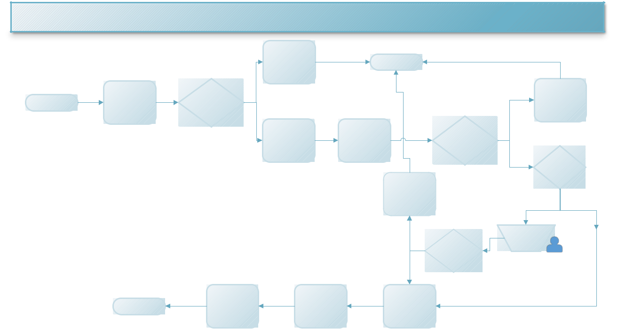

**Detailed AS IS Intercompany Invoice Posting Process MAP**

3

|  |  |  |  |  |  |  |  |  |
| --- | --- | --- | --- | --- | --- | --- | --- | --- |
|  |  |  |  | Send Email to Request | Stop |  |  |  |
|  |  |  |  | the PDF Attachment |  |  |  |
|  |  |  |  |  |  |  |  |
|  | 1 | 2 | No |  |  |  |  | 7 |
|  | Check Email ICO Folder | New Email with PDF |  |  |  |  | Email Team Requesting | |
| Start |  |  |  |  | Vendor Creation | |
| for Emails | Attachment Exist |  |  |  |  |
|  |  |  |  |  |  |  |
|  |  |  |  |  |  | No |  |  |
|  |  |  | Yes | 4 | 5 | 6 |  |  |
|  |  |  |  |  |  |
|  |  |  |  | Log on to SAP | Search for Vendor | Vendor Exist |  |  |
|  |  |  |  |  |  |  |  | 8 |
|  |  |  |  |  |  | Yes | GRN Done For | |
|  |  |  |  |  |  |  |  | Invoice |
|  |  |  |  |  | 11 |  |  |  |
|  |  |  |  |  | Email Team Escalating |  |  |  |
|  |  |  |  |  | Difference |  |  |  |
|  |  |  |  |  |  |  | No | Yes |
|  |  |  |  |  |  | 10 |  |  |
|  |  |  |  |  |  | 9 |  |  |
|  |  |  |  |  | Yes |  | Invoice |  |
|  |  |  |  |  |  | Verification |  |
|  |  |  |  |  |  | Invoice Variance |  |  |
|  |  |  |  |  | No |  |  |  |
|  |  | 14 |  | 13 | 12 |  |  |  |
|  |  | Send Email Notification | | Attach Outlook Email in |  |  |  |  |
|  | End | that the registration is | | Register Invoice in SAP |  |  |  |
|  | SAP |  |  |  |
|  |  | complete |  |  |  |  |  |
|  |  |  |  |  |  |  |  |

*NB: Details Attached*



|  |  |  |  |  |  |  |  |  |
| --- | --- | --- | --- | --- | --- | --- | --- | --- |
|  | Step |  |  | **Short Description of Key Process Steps** |  |  | **AVG** |  |
|  |  |  |  |  |  |
|  |  |  |  |  |  |  | **TAT\*** |  |
|  |  |  |  |  |  |  |  |  |
| ***1*** | |  | *Check Outlook email, For Emails received from Robot Email Address in RPA INV folder.* | | |  |  |  |
|  | |  |  | | |  |  |  |
| ***2*** | |  | *Pick new email, check the email for attachment and available information* | | |  |  |  |
|  | |  |  | | |  |  |  |
| ***3*** | |  | *If the PDF attachment or available information is missing, reply to email provided requesting for the PDF or information to be sent.* | | |  |  |  |
|  |  |  |  | | |  |  |  |
|  | |  |  | | |  |  |  |
| ***4*** | |  | *Logon to SAP, module 720, navigate to menu and SAP TCODE MIRO* | | |  |  |  |
|  | |  |  | | |  |  |  |
| ***5*** | |  | *Search for the vendor No* ***(90028494 Obeikan Graphical Centre)*** *or* ***(90028837 Obeikan Film Factory****) listed on the invoice* | | |  |  |  |
|  | |  |  | | |  |  |  |
| ***6*** | |  | *Check if the vendor entry exists in SAP* | | |  |  |  |
|  | |  |  | | |  |  |  |
| ***7*** | |  | *If the vendor doesn`t exist, send email to request for vendor entry to be created* | | |  |  |  |
|  | |  |  | | |  |  |  |
| ***8*** | |  | *If the vendor exists, Proceed to Invoice Verification if GRN is Done for Invoice and search for available information like date, Inv no, P.O no, DN no, Item No etc. in case of missing information, sent email to procurement, supplier & process owner.* | | |  |  |  |
|  | |  |  | | |  |  |  |
| ***9*** | |  | *If GRN is not Done, send email to concern department to create a GR.* | | |  |  |  |
|  | |  |  | | |  |  |  |
| ***10*** | |  | *Verification of Invoice* ***using P.O No with or without item code or DN*** | | |  |  |  |
|  | |  |  | | |  |  |  |
| ***11*** | |  | *If Variances are noticed Between the Price and Quantity of the Invoice and the PO in* | | |  |  |  |
|  |  |  | *SAP, Email Order Handling Team Escalating Differences (procurement)* | | |  |  |  |
|  | |  |  | | |  |  |  |
| ***12*** | |  | *If GRN is done no Variance is noticed Between the Invoice and DN or PO, Proceed with* | | |  |  |  |
|  |  |  | *Registering Invoice in SAP* | | |  |  |  |
|  | |  |  | | |  |  |  |
| ***13*** | |  | *Attach Outlook Email Title in SAP for future references* | | |  |  |  |
|  | |  |  | | |  |  |  |
| ***14*** | |  | *After the invoice is processed, send an email notification that the action is complete* | | |  |  |  |
|  |  |  |  |  |  |  |  |  |

2.4 Additional sources of process documentation

Below is a list of additional material created to support the process automation, along with the supported documentation provided.



Additional Process Documentation

|  |  |  |
| --- | --- | --- |
| **Video Recording of the process** | *Insert link to the video* | *Date and time of the recording.* |
| **[Mandatory]** | *recording and provide* | *Insert additional relevant comments* |
|  | *access to the video.* |
|  |  |
|  |  |  |
| **List of supporting documents** | *Embed documents* | *List here all the templates, mapping* |
|  |  | *tables, list of URLS supporting Information* |
|  |  |  |



3. To BE Process Description

This chapter highlights the expected design of the business process after automation.

3.1 TO BE Detailed Process Map

**Detailed**

**TO**

**BE**

**Intercompany**

**Invoice**

**Posting**

**Process**

**MAP**

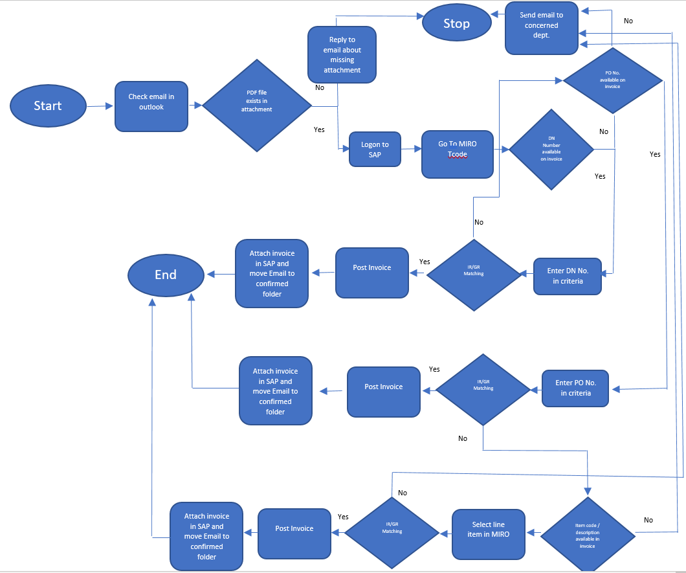

|  |  |  |  |  |  |  |
| --- | --- | --- | --- | --- | --- | --- |
|  |  |  |  |  |  |  |
| *NB: Details Attached* | | |  |  |  |  |
| Step |  | **Short Description of Key Process Steps** | | |  | **AVG** |
|  |  |  |  |  |  | **TAT\*** |
|  |  |  |  |  |  |  |
| ***1*** | *Check Outlook email, For Emails received from Robot Email Address in RPA INV folder.* | | | |  |  |
|  |  | | | |  |  |
| ***2*** | *Pick new email, check the email for attachment and available information* | | | |  |  |
|  |  | | | | |  |
| ***3*** | *If the PDF attachment is missing, reply to email provided requesting for the PDF to be sent.* | | | | |  |
|  |  | |  |  |  |  |
| ***4*** | *Logon to SAP, module 720, navigate to menu* | |  |  |  |  |
|  |  | |  |  |  |  |
| ***5*** | *Go to MIRO T-code* | |  |  |  |  |
|  |  | |  |  |  |  |
| ***6*** | *Enter Delivery Note Number in criteria (if accepted) else;* | |  |  |  |  |
|  | Enter PO number in criteria  If none is available on the invoice, send email to concerned department | | | | |  |
| ***7*** | *If GR and IR are matching, then post the invoice* | | | | |  |
|  | If not matching, then search for Item Number/ Item Description in the invoice and enter in MIRO | | |  |  |  |
| ***8*** | *If GR IR are matching, then post the invoice,* | | |  |  |  |
|  | If not matching, then send email to concerned department and move invoice in “Unprocessed Invoice” folder | |  |  |  |  |
| ***9*** | *Attach the posted invoice and save in folder.* | |  |  |  |  |
|  |  | | | | |  |
| ***11*** | *In Outlook, move the email with the processed attachment to the “Processed” folder* | | | | |  |
|  |  |  |  |  |  |  |

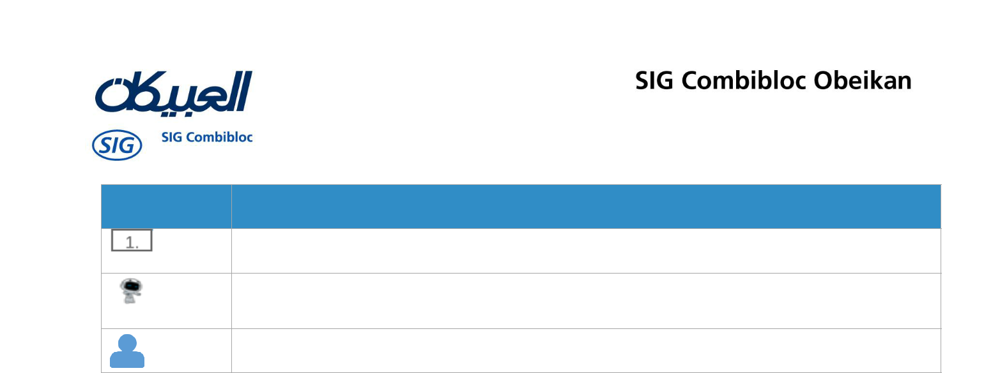

Legend

Step number in the process. Referred in the details or Exceptions and Errors table

This process step is proposed for automation

This process step remains manual (to be performed by human agent)

3.2 In Scope for RPA

The activities **in scope of RPA**, are listed here:

1. *Verify emails for attachments*
2. *Handle exception if attached PDF is missing*
3. *Post data in SAP*
4. *Attach Invoice Copy in SAP*
5. *Send confirmation email*



3.3 Out of Scope for RPA

The activities **OUT of scope of RPA**, are listed here. Mention of the changes/ improvement opportunities identified for automation are out of scope for this automation iteration.

1. *Dispatching the emails into ICO invoices Processed folder*

3.4Business Exceptions Handling

The Business Process Owner and Business Analysts are expected to document below all the business exceptions identified in the automation process. These can be classified as:

|  |  |  |  |  |  |
| --- | --- | --- | --- | --- | --- |
|  | Known |  |  | Unknown |  |
|  |  |  |  |
|  |  |  |  |  |  |
| Previously encountered. A scenario is | | |  | New situation never encountered before. It can be caused by | |
| defined with clear actions and | | |  | external factors. Cannot be predicted with precision, however if it | |
| workarounds for each case. | | |  | occurs, it must be communicated to an authorized person for | |
|  |  |  |  | evaluation. | |
|  |  |  |  |  |  |

**3.4.1** **Known Exceptions**

The table below reflects all the business process exceptions captured during the process evaluation and documentation. These are **known exceptions,** met in practice before. For each of these exceptions, a corresponding expected action that the robot should complete if it encounters the exception has been defined.

|  |  |  |  |  |
| --- | --- | --- | --- | --- |
| **BE #** | **Exception name** | **Step** | **Parameters** | **Action to be taken** |
| *1* | *Multiple invoices for same P.O or DN* | *Step # 8* | *Amount and quantity not matching with the invoice* | *Send email to process owner for manual verification* |
| *2* | *Invoice mandatory details are missing or incomplete (unidentifiable)* | *Step # 3* | *Fields missing or incomplete:* | *send email for additional details: Reply email* |
| *Company name* |
| *Invoice Date* | *Hello"* |
| *Invoice reference no* | *The product details mentioned in the invoice are incomplete or missing. Please check the invoice details and re-send the correct invoice.* |
| *Description* |
| *Quantity* |
| *Tax rate* |
| *Tax No* |
| *Total amount* | [*j.umer@obeikan.com.sa*](mailto:j.umer@obeikan.com.sa) |
| *Contact information* | [*ah.amer@obeikan.com.sa*](mailto:ah.amer@obeikan.com.sa) |
| *P.O no* | [*a.elamin@obeikan.com.sa*](mailto:a.elamin@obeikan.com.sa) |
| *DN no* | *Imran.khan@obeikan.com.sa* |
| *3* | *Missing GR for OGC* | *Step # 9* | *Send email to responsible person to create GR* | *Send email to:* |
| *mokhtar.alhamad@sig.biz* |
| *j.umer@obeikan.com.sa* |
| *Renato.gumban@obeikan.com.sa* |
| "Hello" The GR for attached invoice is missing from SAP. Please create GR entry for it and confirm when it has been done. Thank You" |
|  |
|  |
| *4* | *Missing GR for OFF* | *Step # 9* | *Send email to responsible person to create GR* | *Send email to:* |  |
| *j.umer@obeikan.com.sa* |  |
| *junlie.l@obeikan.com.sa* |  |



**3.4.2 Unknown Exceptions**

For all the other **unanticipated or unknown business (process) exceptions**, the robot should:

*send an email notification at:*

* *Name: Jibran Umer*
* *Senior Accountant*
* [*j.umer@obeikn.com.sa*](mailto:j.umer@obeikn.com.sa%20) *with the original email and error message screenshot attached.*

3.5 Application Error and Exception Handling

Below is a comprehensive list of all errors, warnings or notifications being consolidated here with the description and action to be taken, for each, by the Robot.

Errors identified in the automation process have been classified as:

|  |  |  |  |
| --- | --- | --- | --- |
| Area | Known |  | Unknown |
|  |  |  |  |
| **Technology/** | Experienced previously, action plan |  | New situation never encountered before, or may |
| **Applications** | or workaround available for it. |  | happened independent of the applications used in |
|  |  | the process. |
|  |  |  |
|  |  |  |  |
| **3.5.1 Know Errors or Exceptions** | |  |  |

The table below reflects all the errors identifiable in the process evaluation and documentation.

For each of these errors or exceptions, a corresponding expected action that the robot should complete if it is encountered has been defined

|  |  |  |  |  |  |  |  |  |  |  |  |  |  |  |
| --- | --- | --- | --- | --- | --- | --- | --- | --- | --- | --- | --- | --- | --- | --- |
|  | **AE #** |  |  | **Error name** |  |  | **Step** |  |  | **Parameters** |  |  | **Action to be taken** |  |
|  |  |  |  |  |  |  |  |  |  |
|  |  |  |  |  |  |  |  |  |  |  |  |  |  |  |
| ***1*** | |  |  | *Email stops* | |  | *Any step when working* | |  | *Error message* | |  | *Wait for application to respond.* | |
|  |  |  |  | *responding* | |  | *with outlook. Most* | |  |  |  |  | *Retry.* | |
|  |  |  |  |  |  |  | *frequent when opening* | |  |  |  |  | *Close application and run the sequence* | |
|  |  |  |  |  |  |  | *attachments.* | |  |  |  |  | *again.* | |
|  |  |  |  |  | |  |  |  |  |  | |  |  | |
|  |  |  |  | *SAP logon failure* | |  |  |  |  | *Account deactivated* | |  | *Send email with screenshot to RPA* | |
| ***2*** | |  |  |  |  |  | *Step 4* | |  |  |  |  | *supervisor.* | |
|  |  |  |  |  |  |  |  |  |  |  |  |  |  |  |

**3.5.2 Unknown Errors and Exceptions**

For all the other **unanticipated or unknown application exceptions/errors**, the robot should:

*send an email notification at:*

* *Name: Jibran Umer*
* *Senior Accountant*
* [*j.umer@obeikan.com.sa*](mailto:j.umer@obeikan.com.sa%20) *with the original email and error message screenshot attached*



4. Document Approval

This document requires serial approval (sign off) from the roles defined in the table below. Changes to the requirements must be documented in an updated version (i.e v 2.0) and requires a new signature flow.

|  |  |  |  |  |  |  |  |  |  |  |  |  |  |  |  |  |  |  |  |  |  |  |  |  |
| --- | --- | --- | --- | --- | --- | --- | --- | --- | --- | --- | --- | --- | --- | --- | --- | --- | --- | --- | --- | --- | --- | --- | --- | --- |
|  | Version |  |  | Flow |  |  | Role |  |  | Name |  |  | Organization |  |  | Contact Details | | | | |  |  | Approval |  |
|  |  |  |  |  |  |  |  |  |  |  |  |  |  |
|  |  |  |  |  |  |  |  |  |  |  |  |  | (Dept.) |  |  |  |  |  |  |  |  |  | Date: |  |
|  |  |  |  |  |  |  |  |  |  |  |  |  |  |  |  |  |  |  |  |  |  |  |  |  |
| **1.0** | |  |  | **Document** | |  | ***Technical Solution*** | |  | *Jibran Umer* | |  | *CBOB-Riyadh* | |  | *j.umer@obeikan.com.sa* | | | | | |  |  |  |
|  |  |  |  |  | |  |  | |  |  |  |  |  | |  |  |  |  |  |  | |  |  |  |
|  |  |  |  | **prepared by** | |  | ***Architect*** | |  |  |  |  | *Finance Dept* | |  | *Tel: 0096 540674360* | | | | | |  |  |  |
|  | |  |  |  | |  |  | |  |  | |  |  | |  |  |  | | |  | |  |  |  |
| **1.0** | |  |  | **Document** | |  | ***Process Owner*** | |  |  | |  | *CBOB-Riyadh* | |  |  | | | | | |  |  |  |
|  |  |  |  | **Approved by:** | |  |  |  |  |  |  |  | *Finance Dept* | |  |  | | |  | | |  |  |  |
|  | |  |  |  | |  |  | |  |  | |  |  | |  |  | | | |  | |  |  |  |
| **1.0** | |  |  | **Document** | |  | ***Operations*** | |  |  | |  | *CBOB-Riyadh* | |  |  |  | | | | |  |  |  |
|  |  |  |  | **Approved by:** | |  |  |  |  |  |  |  | *Finance Dept* | |  |  | | | | | |  |  |  |
|  | |  |  |  | |  |  | |  |  | |  |  | |  |  | | | | | |  |  |  |
| **1.0** | |  |  | **Document** | |  | ***Compliance*** | |  |  | |  | *Regional Audit* | |  |  | | | |  | |  |  |  |
|  |  |  |  | **Approved by:** | |  |  |  |  |  |  |  |  |  |  |  | | | | | |  |  |  |
|  | |  |  |  | |  |  | |  |  | |  |  |  |  |  |  |  |  |  |  |  |  |  |
| **1.0** | |  |  | **Document** | |  | ***RPA Architect/*** | |  | *Name Surname* | |  |  |  |  |  |  |  |  |  |  |  |  |  |
|  |  |  |  | **Approved by:** | |  | ***Developer*** | |  |  |  |  |  |  |  |  |  |  |  |  |  |  |  |  |
|  |  |  |  |  |  |  |  |  |  |  |  |  |  |  |  |  |  |  |  |  |  |  |  |  |

